ELKHART COUNTY HEALTH DEPARTMENT
TEMPORARY FOOD SERVICE GUIDELINES
574-971-4600

This document will serve as a guideline for temporary food service owners to use when considering the setup, design, and menu of a temporary food service. A temporary food establishment is a retail food establishment that operates for a period of no more than fourteen consecutive days in conjunction with a single event or celebration. A single event or celebration is a gathering associated with an occasional or special but recognized event sanctioned and sponsored by a governmental unit, charity, civic group, or fraternal order. It shall not include an individual or group preparing food items for a limited time when not associated with such recognized events. Temporary licenses cannot be issued for garage sales, weekly ball games, or just for someone to set up on the corner to make money.

The following items are highlights from the Indiana Food Service Sanitation Regulations 410 IAC 7-24 (found at https://www.in.gov/isdh/files/410_iac_7-24.pdf) and the Elkhart County Food Service Ordinance and are intended to be helpful but not all-inclusive.

FOOD/FOOD PROTECTION:
According to Indiana regulation 410 IAC 7-22, after Dec. 31, 2004, at least one food handler at a food establishment must be a certified food manager.
The certified food manager requirement does not apply to a food establishment when the food establishment’s food handling activities are limited solely to one or more of the following:
- Heating or serving precooked foods.
- Preparing or serving a continental breakfast such as rolls, coffee, juice, milk, and cold cereal.
- Preparing or serving nonalcoholic or alcoholic beverages that are not potentially hazardous or ice.
- Preparing or serving packaged or unpackaged foods that are not potentially hazardous foods, including elephant ears, funnel cakes, cotton candy, confectionaries, baked goods, popcorn and chips, and grinding coffee beans.
- Providing prepackaged food in its original package.

All food must be from a licensed facility. Home canned, baked or prepared foods are not allowed. Only those potentially hazardous foods (i.e. meats, dairy products, eggs, seafood, etc.) that require limited preparation on site are acceptable for use.

Internal temperatures of all potentially hazardous foods shall be maintained at 135ºF or above if hot and 41ºF or below if cold, at all times. This includes storage, preparation, display, service, and transportation.

Stab type or probe thermometers accurate to plus or minus 2°F must be provided to accurately monitor the temperature of potentially hazardous food during preparation, storage and display. Protected thermometers accurate to 3°F must be provided in all refrigeration and hot holding units.

Potentially hazardous food shall be thawed only under refrigeration or as a part of the cooking process. Under no condition is it acceptable to thaw food at room or air temperature.

All raw meats must be stored under or away from all non-potentially hazardous products or products that will be served with no further cooking to prevent cross contamination.

All foods are to be covered in storage and must be at least 6 inches above the floor on a clean, dry, well protected area to prevent contamination.

Provide and use dispensing utensils with handles or food grade gloves to prevent bare hand contact with foods. Bare hand contact with ready-to-eat foods is prohibited.

Ice, which will contact food or mouth contact surfaces of a product must be from an approved source and treated as a food. All ice must be in a self-draining, cleanable, non-absorbent container. All bulk storage of ice must be at least 6 inches above the ground in a clean, dry, well-protected area. Styrofoam containers are not acceptable for ice storage.

Only high temperature cooking units (i.e. charcoal grills) may be located outside of the unit and then only if they can be protected from contamination, covered and out of reach of the consumer. There must be a hand wash station accessible outside if cooking or prepping will occur outside of the unit.

PERSONNEL

A conveniently located hand wash is required in all food preparation areas. Hot or tempered water, soap and paper towels are required. In rare circumstances a large insulated container with warm water may be used where water under pressure is not available.

Employees shall thoroughly wash their hands and the exposed portions of their arms with soap and warm water before starting work, after eating, smoking, drinking, or using the toilet, and as often as necessary to keep them clean.

All employees with infectious diseases must be excluded from work. Employees with less serious illnesses, cuts or burns must have their activities restricted so as not to contaminate or infect food or food contact surfaces.

Employee clothing must be clean and their hair effectively restrained by a hat, hair net, or other device which effectively restrains the hair and reduces or eliminates hand contact.

EQUIPMENT AND UTENSILS

No enamel or porcelain equipment allowed. No enamel roasters.

No bare wood surfaces or contact paper allowed. All food and non-food contact surfaces must be smooth, non-absorbent, durable, easily cleanable and light in color.

A three-compartment sink must be provided for the proper washing, rinsing and sanitizing of table and kitchenware.

Warm water, detergent and an approved sanitizer must be provided for the washing, rinsing, and sanitizing procedure. Acceptable levels of chlorine (bleach) sanitizer are 50 to 100 parts per million. Acceptable level of a commercial Quaternary Ammonia sanitizer is 200 parts per million. This is not the same as household ammonia. A test kit shall be provided to monitor these levels.

All kitchenware, after being washed, rinsed and sanitized must be air-dried. Towel drying is not acceptable.

Wiping cloths must be clean, rinsed frequently in clear water, and stored in a labeled container of sanitizing solution between uses. Do not add soap to sanitizing solution.

All equipment must be cleaned and sanitized between uses. Clean equipment is to be stored in an inverted position, in a clean dry area, in a manner that protects from contamination.

All utensils in between use are to be stored in the product with handles extended or clean in a protected location.

SINGLE SERVICE ITEMS

All single service items and paper goods must be stored at least 6 inches above the floor and the packaging of bulk supplies kept closed. Only single service utensils may be provided for customer use.

Single service items are to be presented to the customer from a dispensing container that makes the handle only, and not the mouth or food contact surfaces, available to the customer. All single service utensils are to be stored with the handles extended, not mouth or food contact surfaces. Cups are to be kept in their protective sleeve and opened so that the bottom not the mouth surface is exposed. Where possible all single service cups are to be dispensed from a dispensing tube.

WATER SUPPLY

A suitable water supply shall be available to meet all of the needs and uses of the temporary food service and shall include water necessary for product, hand, and utensil washing.

All water must be from an approved supply. Water is to be under pressure with no cross connections and suitable back flow and back siphonage devices in place between the unit and the water supply. When there is a shut off down stream of the water supply, a constant pressure backflow prevention device (pictured below) is required. (Watts 9-D or similar quality)
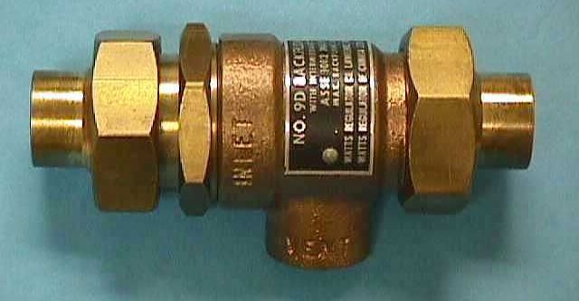

Where water under pressure is not available, suitable sanitary water supply holding tanks must be provided.

Water supplied to the unit is to be through water grade piping or a single food grade, not garden grade, hose. Where it is necessary to join an additional water hose, that connection must be elevated not less than 6 inches above the ground surface and protected from contamination.

WASTE WATER DISPOSAL

All liquid wastes must be captured in a closed holding tank and held for disposal in a sanitary sewage system or they must discharge directly to the sanitary sewer through the proper indirect connection. There may be no discharge of sanitary or gray water wastes directly to the ground surface. Clear water waste, such as the clear water discharge from ice melt may be discharged to the ground so long as nuisance conditions are not created.
Wastewater holding tanks must be at least 15 percent larger than the potable water supply tanks.

INSECT AND RODENT CONTROL

All outer doors must be self-closing and kept closed. If ventilation is required then all such doors must be fitted with self-closing screens.

All service windows or openings are to be protected from the entrance of flies or other insects through the use of screens or air curtains that cover the entire opening. All service windows or screens are to be self-closing and are to be kept closed when not in continuous use. In some limited operations, fans may be acceptable to prevent the entrance of insects but must be approved prior to the event and will not be acceptable in all cases.

All trash receptacles and exterior trash or refuse containers are to be emptied frequently or they must be kept covered between uses.

STRUCTURE

Each temporary food service shall provide a suitable structure for all storage, preparation, and serving of food. The completeness of the structure required is dependent upon the product prepared and the amount of preparation necessary. Prepping food outside is not allowed. At a minimum, the unit must have the following:

1.Cleanable walls that protect product from traffic, insects, and blowing soil

2. The unit must have a cleanable floor or removable platform in good condition.

3. The unit must have a durable roof and cleanable ceiling to protect the workers and the food service from the elements, insects and birds.

4. The unit must be provided with an adequate amount of protected lighting to facilitate the thorough cleaning of the unit and all interior surfaces.

5. The unit must be provided with adequate ventilation to remove excessive heat, steam, smoke or grease. All fat fryers must be properly vented to the outside of the unit.

MISCELLANEOUS

All toxic materials and cleaning supplies must be stored separate and under paper goods and all food.

The food service license is to be posted and clearly visible to the public at all times.

The attached pages provide only minimum requirements. Limited operations, those serving only prepackaged products or doing very little preparation don’t require as much as those with more hazardous products. To find out the specifics for your operation you should call the Elkhart County Health Department Environmental Division at 574-971-4600. Field staff is generally available to answer your questions between the hours of 8 am and 10 am, Monday through Friday, or will return your call.

All temporary food service units are to be inspected and licensed prior to opening. Elkhart County law requires the unit to be substantially in compliance prior to licensing or operation. The licensing fee is $55.00 for events lasting 1 to 7 days and $100.00 for events lasting 8 to 14 days at a single location in conjunction with a single event or celebration. Any organization that is Not-for-Profit may be exempted from the fee and inspection under Indiana Law if they choose by providing a copy of their gross income tax exempt certificate to the health department prior to or at the time of licensing. Registration of Not-for-Profit organizations is required under Elkhart County Ordinances. Failure to prove Not-for-Profit status will require payment of the County temporary food service license fee and compliance with all other applicable laws.

Pre-inspection of your unit can often be arranged prior to the event to facilitate operations the actual day of operation. This often allows for any minor corrections that may be necessary and also allows for a majority of the paperwork to be completed prior to both of us being very busy on event day.

Handwashing Station Must be Accessible in the stand.

Elkhart County Health Department
“Dedicated to a Healthful Life and Environment"

Minimum Requirements For Temporary Handwashing
Stations

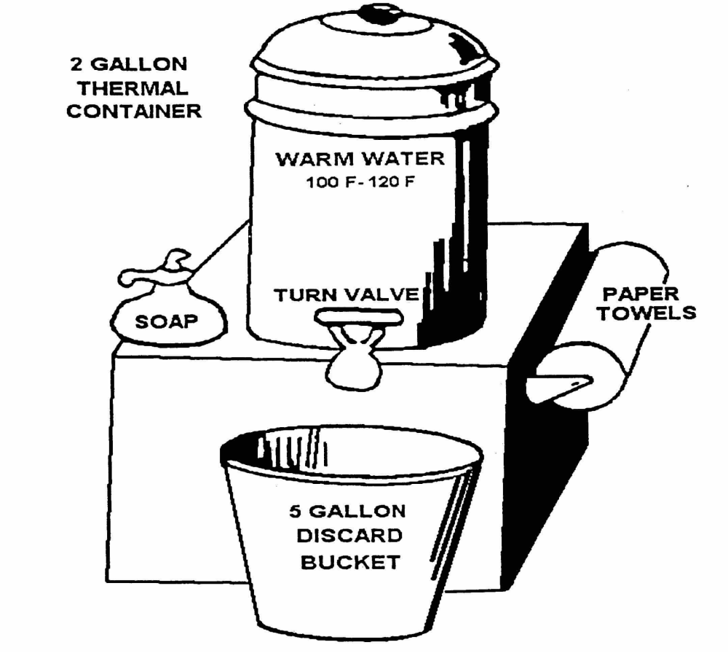
Any booth found without adequate handwashing facilities as described above will be closed until adequate handwashing facilities can be provided.

