HEALTHY HEART SERIES

Healthy Heart - Kindergarten
Healthy Heart is an interactive program that teaches basic information about the heart and how to keep it healthy. Facts about the heart as well as nutrition, exercise and tobacco are discussed. A variety of hands-on activities are integrated in the program including listening to a beating heart and observing a real pig's heart.
Exercise - Grade 1
This program continues building on the concepts introduced in the Healthy Heart program with an emphasis on the benefits of regular exercise. Students will have the opportunity to participate in a variety of activities that will enhance their understanding and enjoyment of physical fitness.

Nutrition - Grade 2
The third session in a series of interactive programs intended to provide students with increasing knowledge to maintain a healthy heart. Basic nutrition concepts including Choose MyPlate (food groups), healthy drink choices and the importance of eating breakfast are introduced.

Healthy Lifestyle - Grades 4-12
Through activities centered on Choose MyPlate, the food label, portion sizes and physical activity students will learn how to develop and maintain a healthy lifestyle.

SAFETY SERIES

Home Alone - Grades 3-5
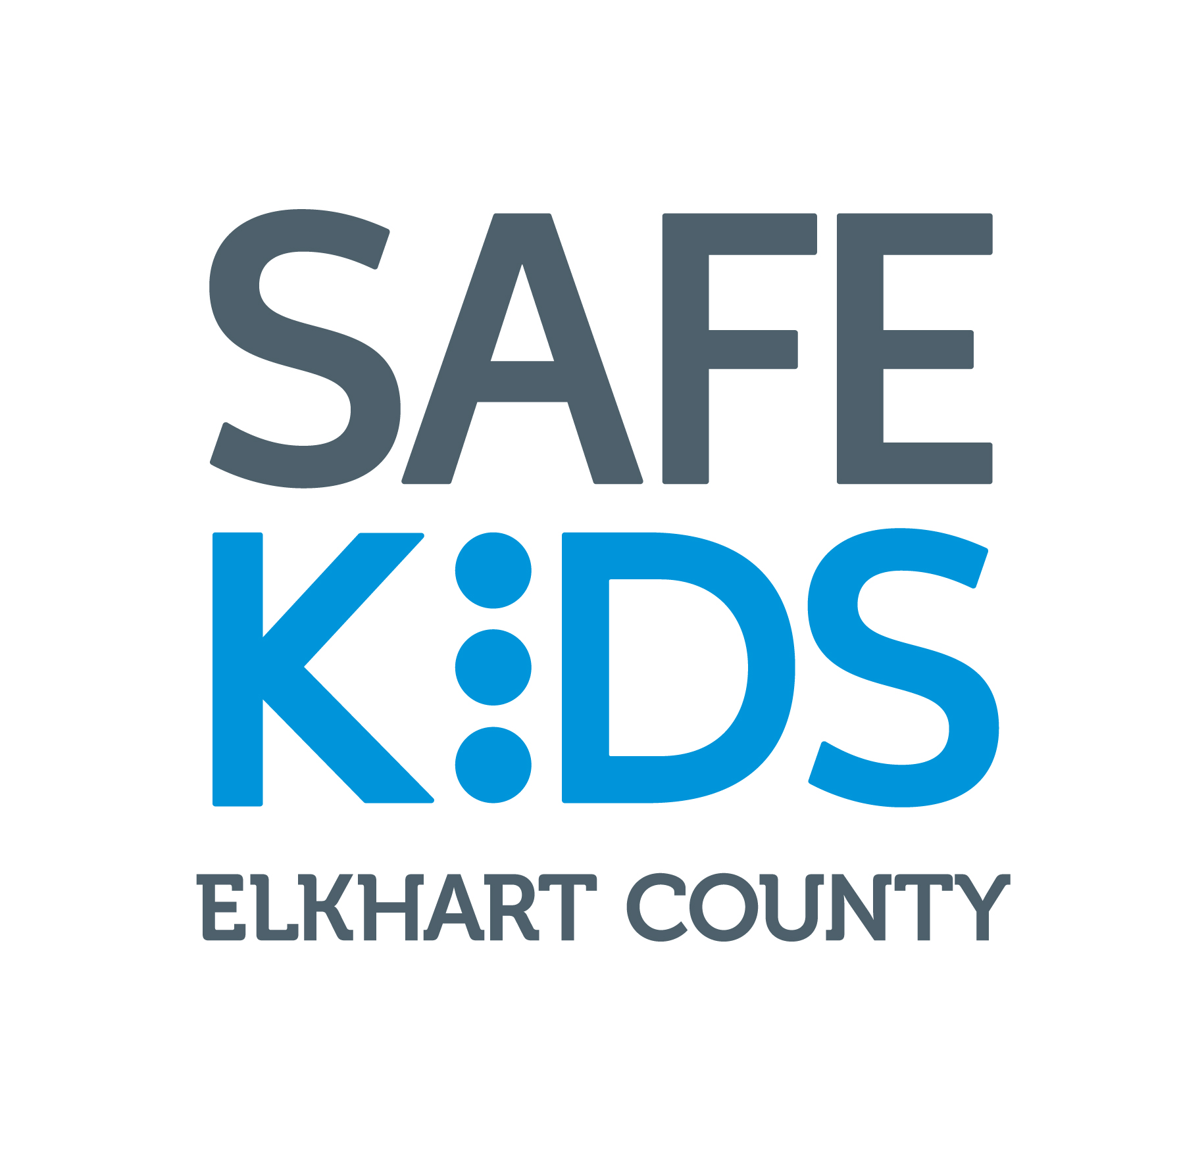
The Home Alone program is designed to provide children 9 years and older with the necessary skills and knowledge to be safe and responsible when home alone for short periods of time. It will help them understand how to prevent problems, handle real-life situations, and keep them safe and constructively occupied.

Pedestrian/Wheel Safety - Grades K-3
Program focuses on overall safety guidelines for students engaging in pedestrian and wheel activities. Concepts such as safe methods to cross streets, avoiding danger and traffic rules are covered. The use of helmets and proper safety gear are strongly emphasized and demonstrations are provided.
Emergency Preparedness - Grades 3-5
This program focuses on emergencies and how students can prepare for them at home. From fire safety to natural disasters, they will exercise their investigative, creative and communication skills to demonstrate their understanding of emergency preparedness.

Poison Safety - Grades K-2
Students will learn how to identify common household poisons through an interactive game. This program teaches safe behaviors and steps for how to respond in an emergency situation.

WELLNESS SERIES

Personal Hygiene - Grades 4-12
This program emphasizes the social and health benefits of daily cleanliness from bathing to dental care. It also describes the components of body odor and how hygiene practices reduce or eliminate these elements. Regular hand washing is also emphasized for good health.

Puberty/Growth & Development - Grades 4-6
Puberty is a period of rapid growth and change in a child’s life. These changes can be intimidating and confusing for children to navigate alone. With this in mind, these programs are designed to help educate students on the causes of puberty, what they can expect their body to go through, and how they can prepare for this new period of their lives. Our educators discuss physical and emotional changes with a special emphasis on healthy lifestyle choices that empower students to take control of their unique puberty experience. This program can be gender specific or include information on both genders depending on your needs. New laws put in place by the State of Indiana now dictate that special opt-out rules are followed for all forms of sexual education. Please expect one of our educators to reach out to you to help ensure we remain in compliance with the state.

Sexually Transmitted Infection and Sexual Consequences – Grades 5-8
Our STI and Sexual Consequences program is designed to inform and educate students on the risks associated with engaging in sexual activity. This program discusses healthy boundaries, respectful relationships, the concept of sexually transmitted infections and overviews the most common STI’s found in Elkhart County. Please be aware that the state of Indiana has guidelines for abstinence and contraceptive use that will dictate how our educators deliver the materials. Our educators will contact you after your request is received to discuss the State of Indiana’s new rules regarding these programs. A stand-alone HIV/AIDS program is available by request.

Healthy Relationships - Grades 5-12
This program focuses on teaching students about appropriate behaviors and interactions within a variety of interpersonal relationships. Characteristics of positive and negative relationships are addressed, along with the effects of social media on relationships.

Stress Management - Grades 5-12
This program teaches students how to identify the causes of stress and what can be done to reduce stress. The negative effects of stress at school, at home or in their personal lives are also addressed.

The TRUTH about Alcohol and other Drugs - Grades 4-6
This presentation is designed to help students understand the potential dangers and health risks of using alcohol, tobacco and other drugs. The legal aspects are highlighted and refusal and resistance skills discussed. The concept of “social norming” (emphasizing that a large majority of youth choose to abstain from use) will be introduced. This series can be tailored to address specific topics (i.e. marijuana and prescription drugs, etc.).

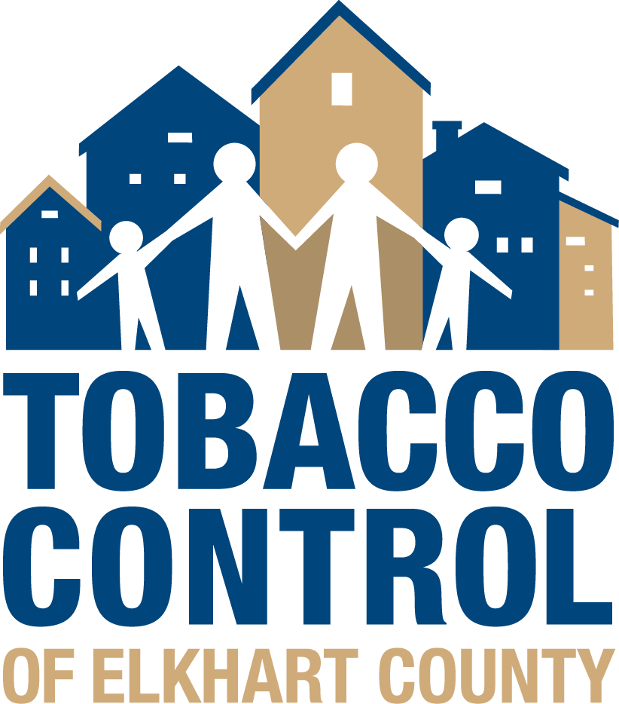
The TRUTH about Tobacco, Electronic Cigarettes & Vaping - Grades 7-12
In 2018, more than 1 in 5 Indiana high school students and nearly 1 in 12 Indiana middle school students reported current (past 30 day) use of any tobacco product. Electronic cigarettes (e-cigarettes) specifically JUUL were the most commonly used tobacco product among Hoosier youth, followed by cigars, cigarettes, and smokeless tobacco. Cigarette smoking remains the leading cause of preventable death in the United States. Nearly 90% of adult smokers started smoking before the age of 18, and 95% by age 21. According to the 2018 National Youth Tobacco Survey (NYTS) data, there is an astonishing increase in kids’ use of e-cigarettes and other electronic nicotine delivery systems (ENDS), reversing years of favorable trends in our nation’s fight to prevent youth addiction to tobacco products. This presentation focuses on the health effects of tobacco use, how tobacco products are priced and marketed to teens, and cessation options for youth and their families.

***In addition to The TRUTH about Tobacco, Electronic Cigarettes & Vaping programming, schools can access and deliver the following program:

CATCH My Breath – Youth E-Cigarette & JUUL Prevention Program
Free to U.S. Schools
Thanks to support from donors and lead sponsor, CVS Health
Ages 10-18 Years (Grades 5-12)
Four Lessons per Version (30-40 Minutes each)

CATCH My Breath is a best-practices youth E-cigarette and JUUL prevention program developed by The University of Texas Health Science Center at Houston (UTHealth) School of Public Health. The program provides up-to-date information to teachers, parents, and health professionals to equip students with the knowledge and skills they need to make informed decisions about the use of E-cigarettes, including JUUL devices. CATCH My Breath utilizes a peer-led teaching approach and meets National and State Health Education Standards. For program information and enrollment please visit www.catchmybreath.org.

